Project Design Phase-II
Technology Stack (Architecture & Stack)

Date | 02 November 2025
Team ID | NM2025TMID07661
Project Name | Streamlining Ticket Assignment for Efficient  Support Operation
Maximum Marks | 4 Marks

Technical Architecture:
The Deliverable shall include the architectural diagram as below and the information as per the table1 & table 2
Example: Order processing during pandemics for offline mode

Reference: https://www.freshworks.com/freshservice/it-ticketing-system/

Guidelines:
• Include all the processes such as Ticket Assignment, Workload Monitoring, Ticket Prioritization, Notifications, and Reporting
(as application logic / technology blocks)
• Provide infrastructural demarcation by showing:
- Local side → Users (Customer, Agent, Team Lead)
- Cloud side → Backend services, Authentication, Database, Analytics
• Indicate external interfaces such as:
- Email / SMS Notification API
- Optional CRM / ITSM integration API
• Indicate Data Storage components / services such as:
- Ticket Database
- Agent Skill & Workload Database
- Logs / History Database
• Indicate interface to Machine Learning Models (if applicable) for:
- Automatic ticket prioritization
- Smart workload-based ticket routing

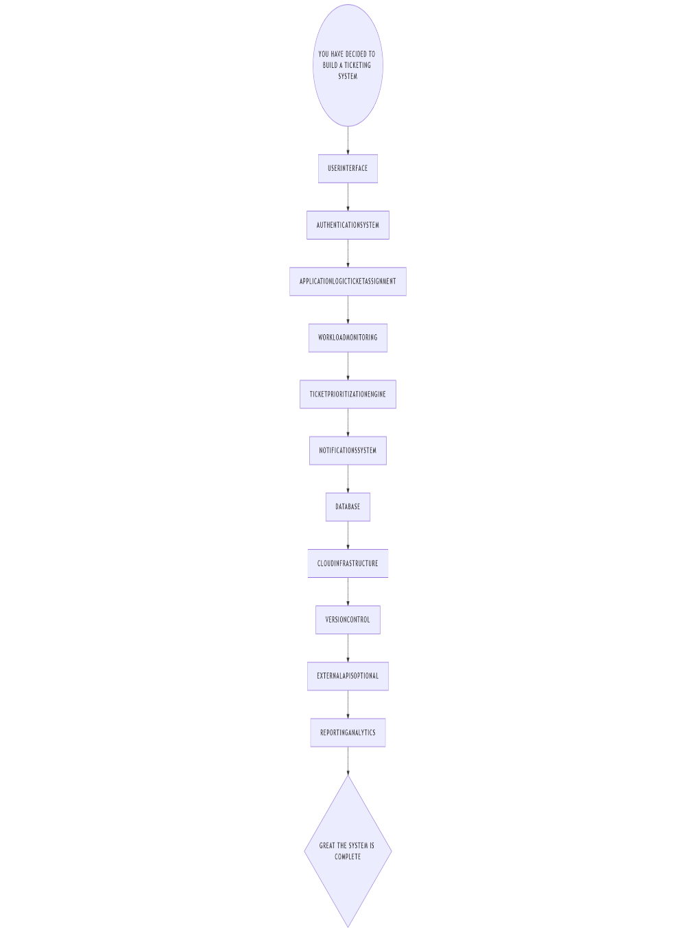

Table-1 : Components & Technologies:
S.No | Component | Description | Technology
1. | User Interface | Web portal for customers, agents & leads to raise, view and manage support tickets | ServiceNow Web UI
2. | Application Logic-1 | Automatically assigns tickets based on priority, skill & workload | ServiceNow Flow Designer, Script
3. | Application Logic-2 | Tracks agent workload in real-time for fair ticket distribution | GlideRecord in Server Script
4. | Application Logic-3 | Sends notifications for new assignments, escalations & SLA alerts | ServiceNow Notifications
5. | Database | Stores tickets, user profiles, skillset & workload details | ServiceNow CMDB, Incident Tables
6. | Cloud Database | ServiceNow-managed backend database | ServiceNow Cloud Database
7. | File Storage | Stores activity logs & system records internally | ServiceNow system logs
8. | External API-1 | Integration with CRM or email/SMS gateways for ticket alerts | REST API in ServiceNow
9. | External API-2 | Not applicable | -
10. | Machine Learning Model | For predictive ticket routing and smart assignment decisions | -
11. | Infrastructure (Server / Cloud) | Fully hosted and managed in ServiceNow environment | ServiceNow Cloud (SaaS)

Table-2: Application Characteristics:

S.No | Characteristics | Description | Technology
1. | Open-Source Frameworks | Not applicable (ServiceNow is proprietary) | -
2. | Security Implementations | Secure role-based access for Customers, Agents & Leads. Ensures only authorized users can view/modify tickets. | ACLs, Scoped Applications
3. | Scalable Architecture | Supports increasing number of tickets and support agents seamlessly through cloud scalability | ServiceNow Cloud Architecture
4. | Availability | Platform remains active 24/7 ensuring continuous support operations globally | Load-balanced ServiceNow Instances
5. | Performance | Fast ticket assignment & workflow execution with optimized queries and processing | GlideRecord, Asynchronous Flows, Background Scripts

